**SC1104 Mar 2022: Tutorial 5**

Q1) Lay 6.1/pg 336/Q1

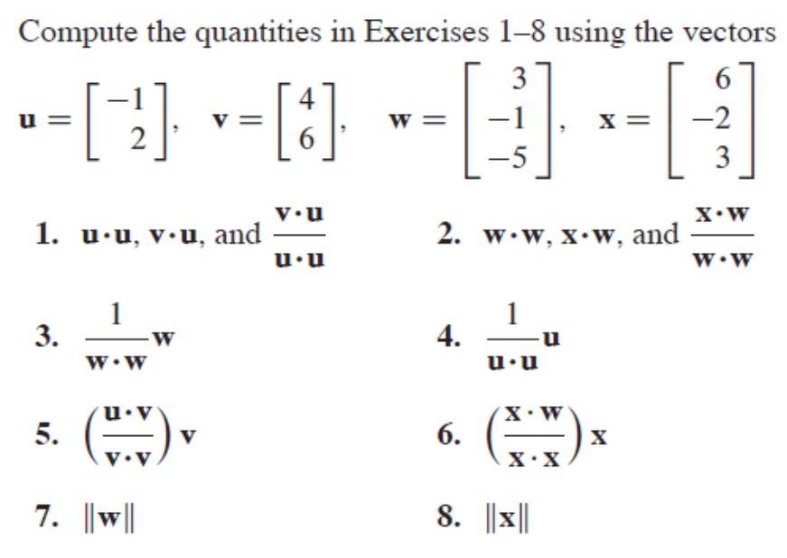

Ans Q1:

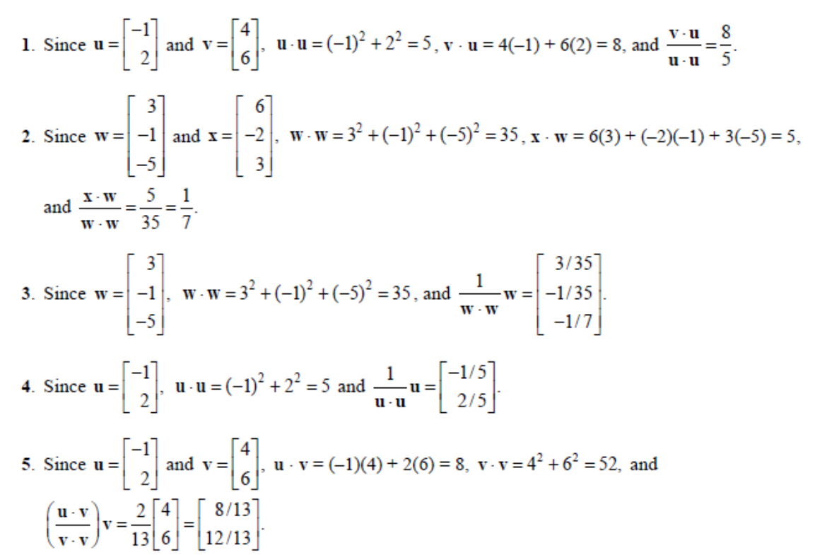

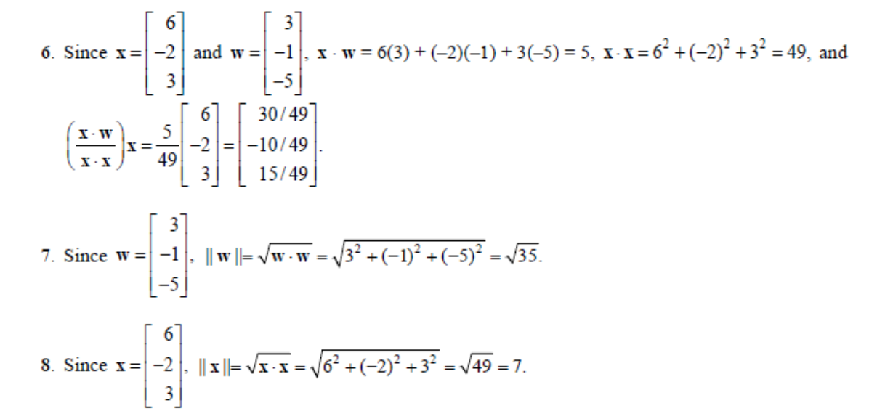

Q2) Lay/ pg 337/ Q19

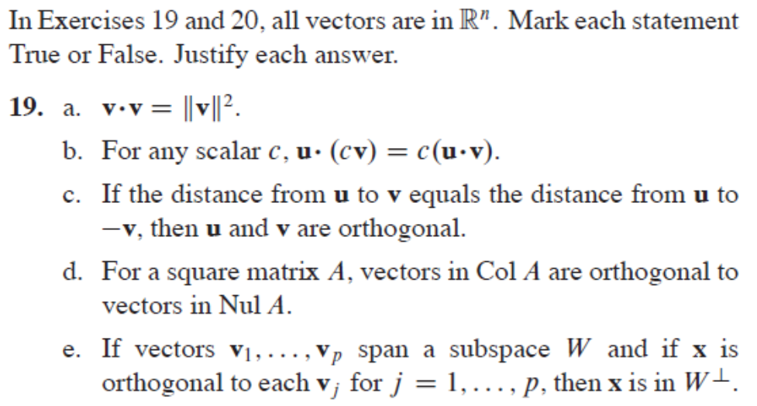

Ans:

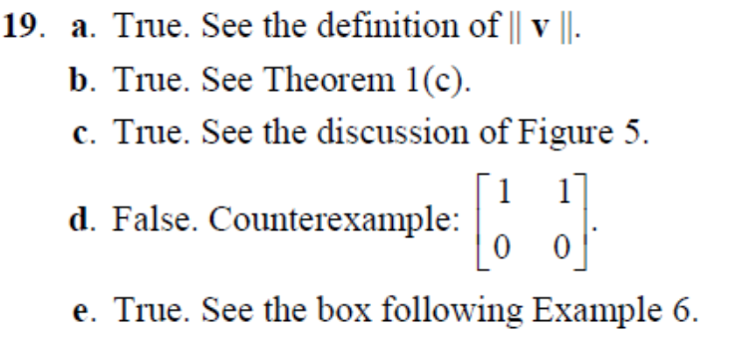

19c (detailed answer):





19e: If x is orthogonal to each vi in W, x will be orthogonal to all linear combo of vi.

Hence x perpendicular to W.

Q3) Lay Q30)

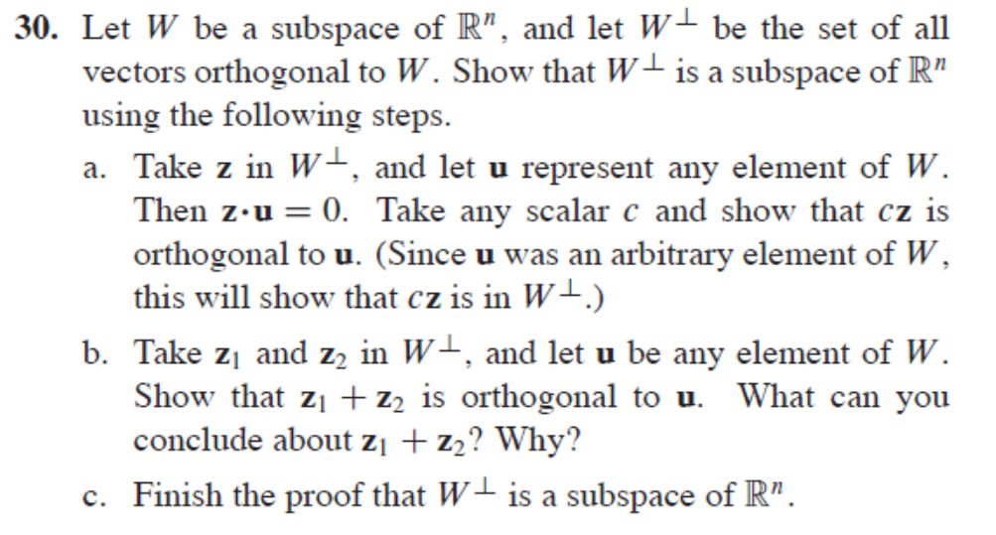

Ans:

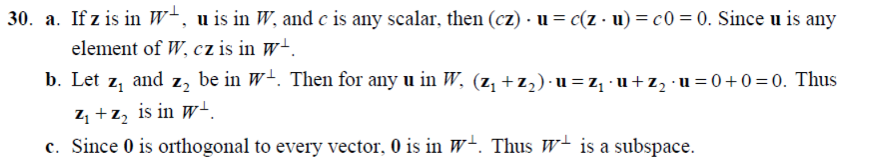

Maths/LA/Tut6.2/Orthogonal Sets

Q4) Lay Example 3, pg 340

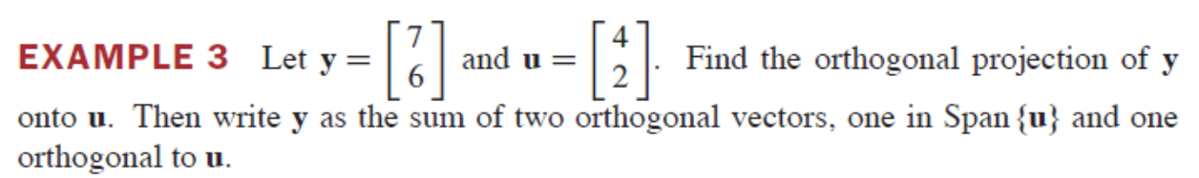

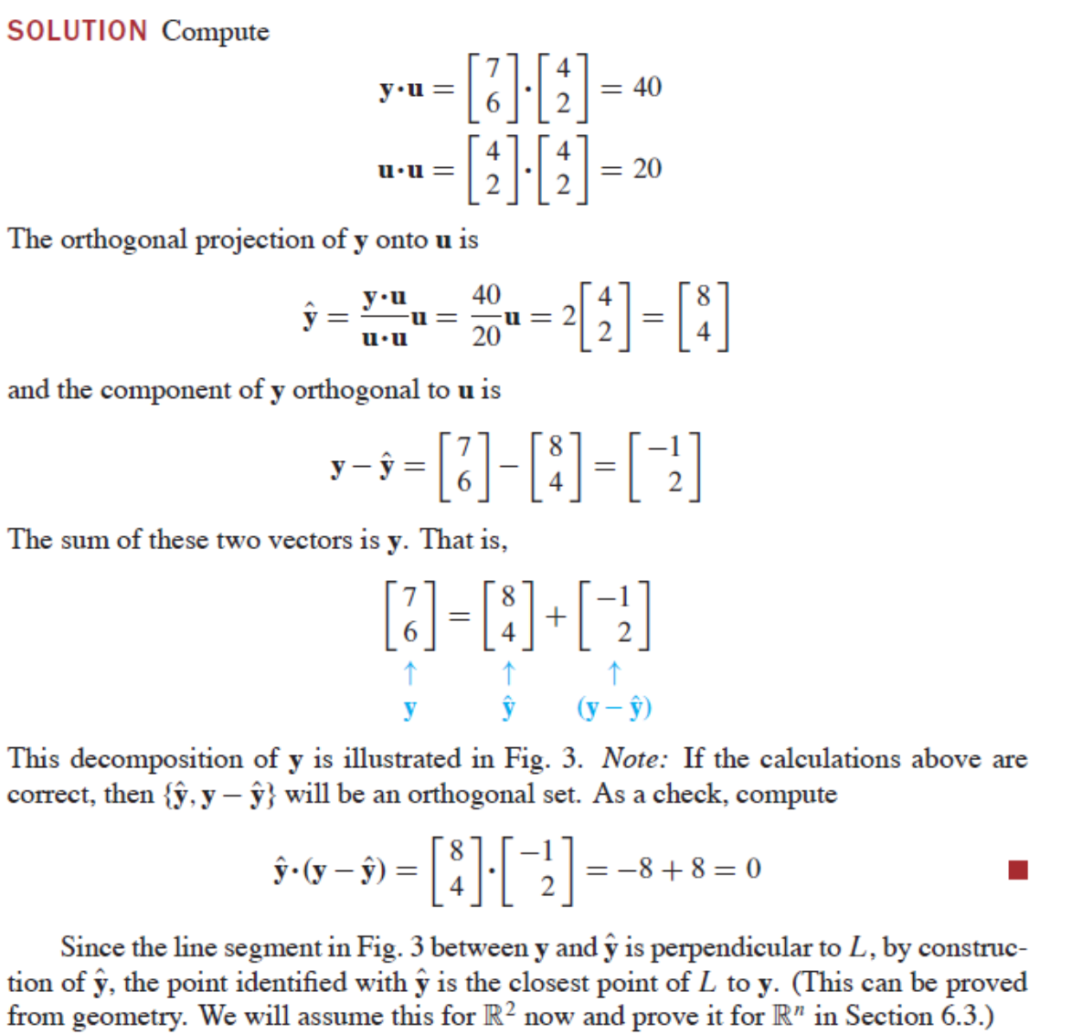

Q5) Lay/pg 345/Q17

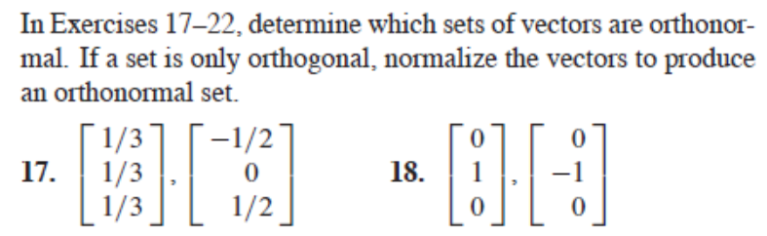

Ans:

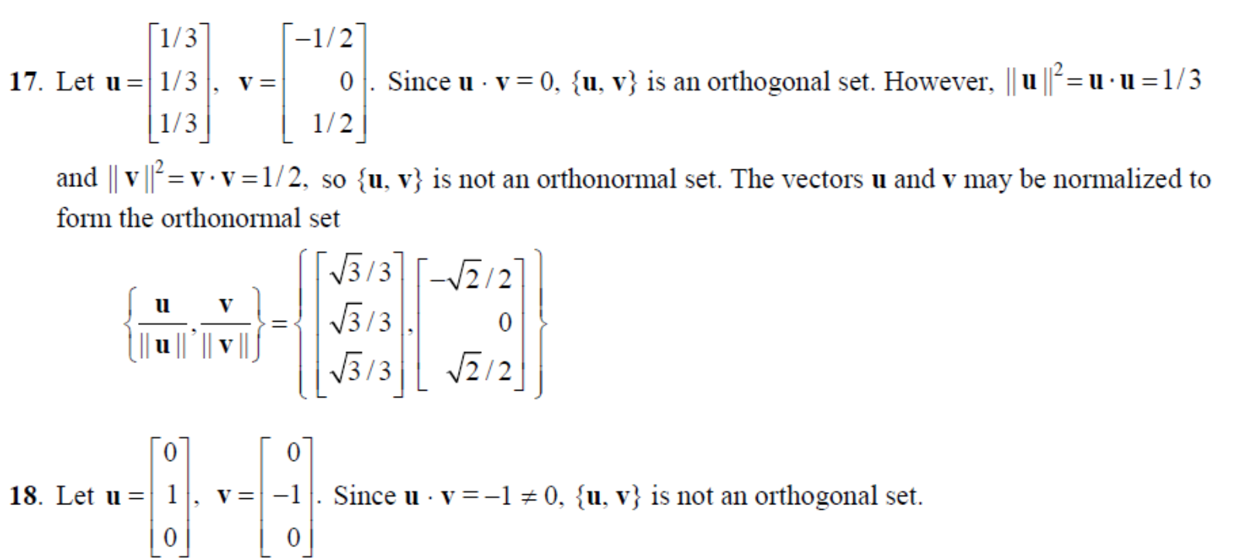

Q6) Lay/pg 345/Q23+24

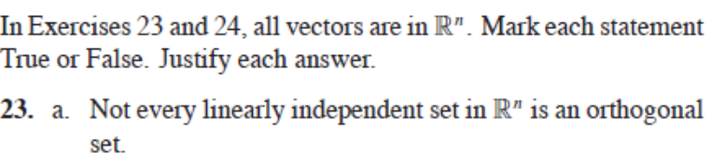

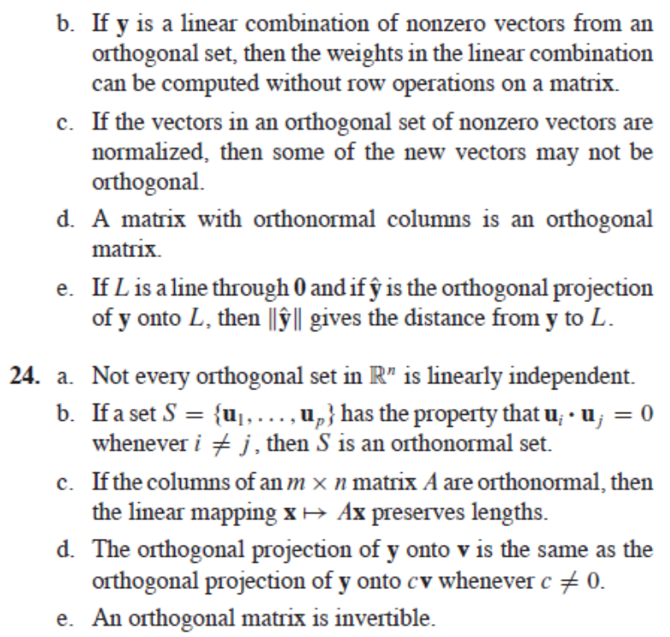

Ans:

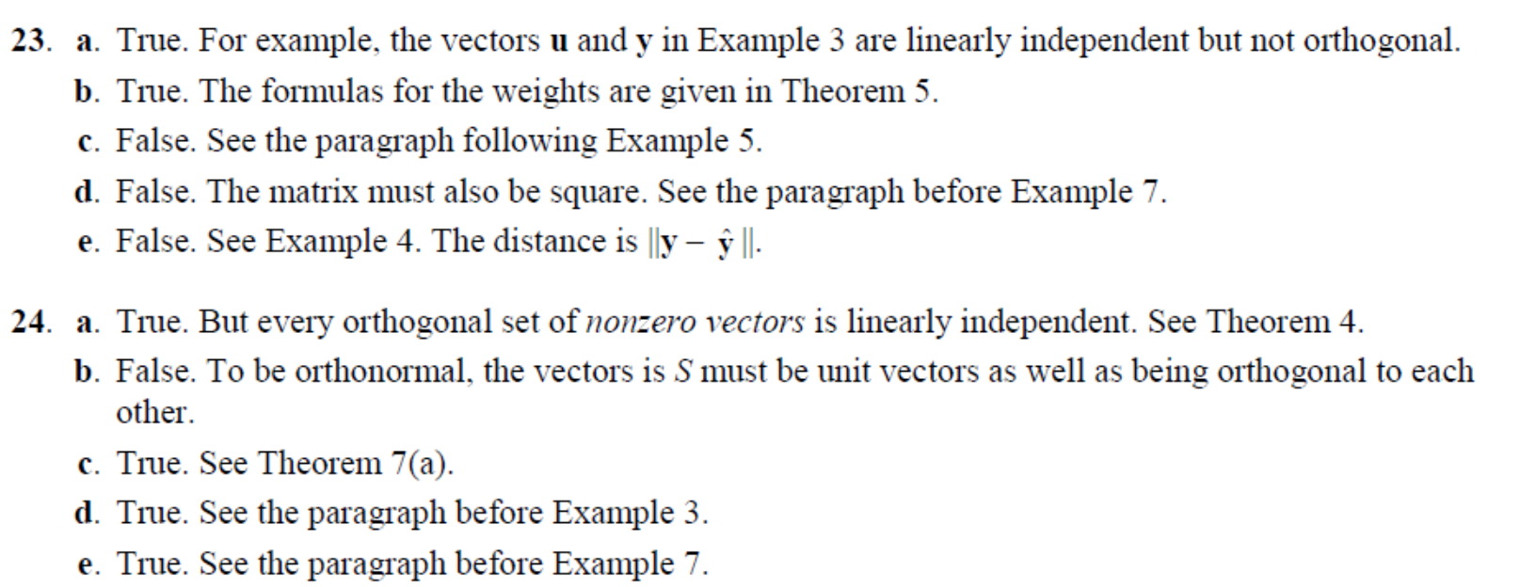

Details of some Answers Q23:

1. {(1,0),(1,1)} are independent but not orthogonal.
2. Scaling size of vectors does not change angles between vectors.

Details of some Answers Q24:

24a. Typo. Answer false. Every orthogonal set is independent. In class Orthogonal set DOES not contain zero vector in our definition.

24c. *A***u·** *A* **v** = (*A* **u**)*T A* **v** = (**u** *T AT* )*A* **v** = **u** *T* (A*T A* )**v** =**u** *T* **v** =**u· v**.

Replace v by u, we get ||Au||=||u||

24e. Q orthogonal implies *Q* *T Q* = Id. Hence Q invertible.

Q7) Lay/pg 345/Q31

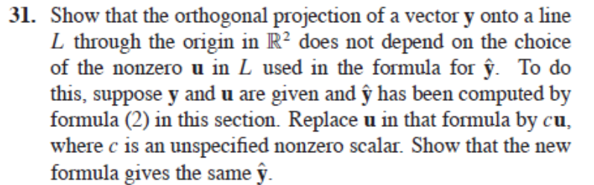

Ans:

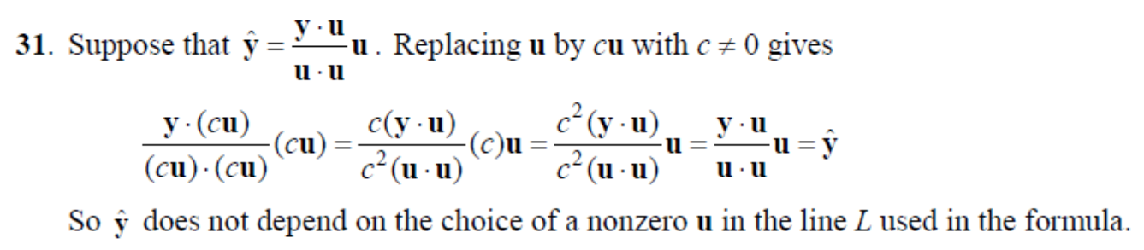

Tut6.3/OrthogonalProjection and GramSchmidt/

Q8) Lay/pg351/Example3/Example4

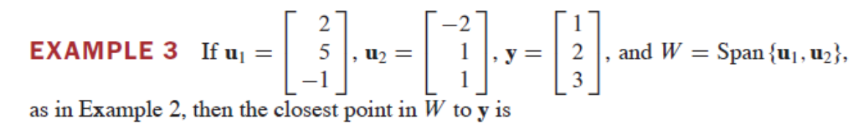

Ans: 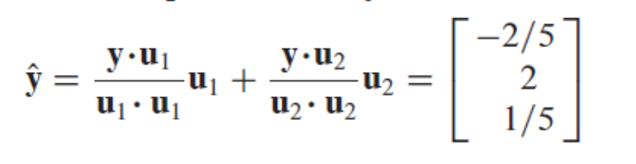

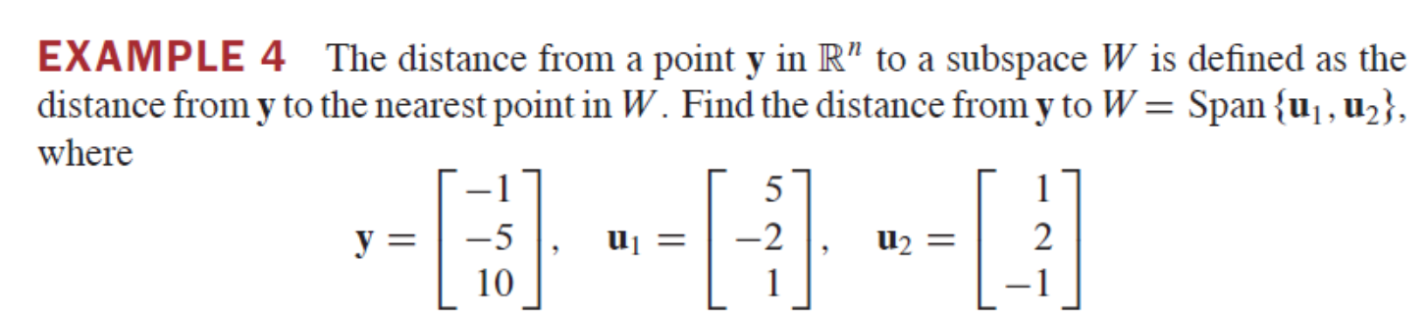

Ans:

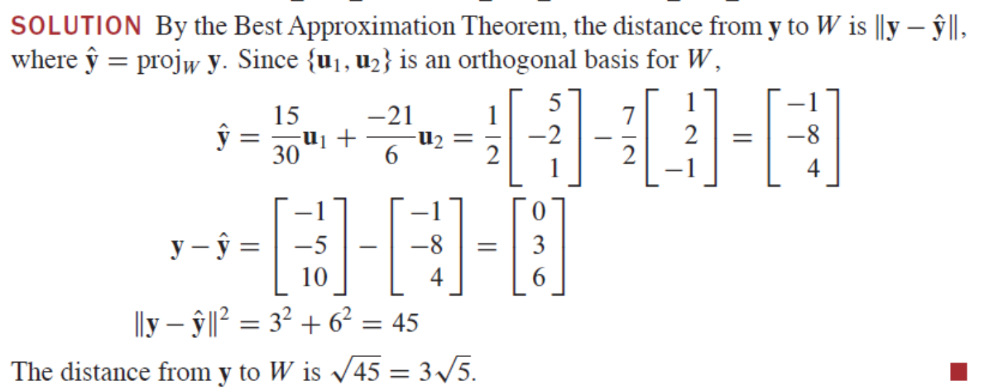

Q9) Lay/pg353/Q21+22

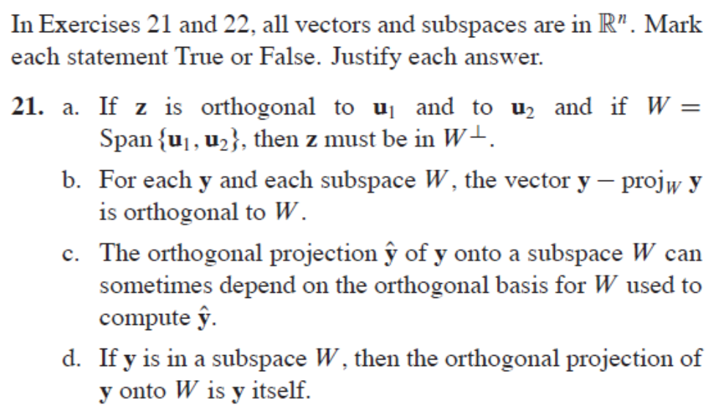

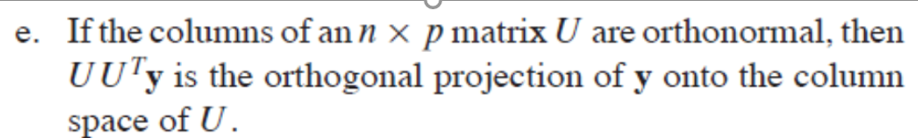

Ans:

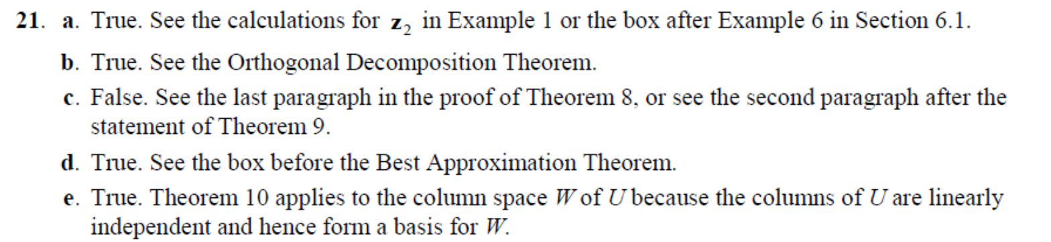

Q10) Lay/pg 359/Q19+20

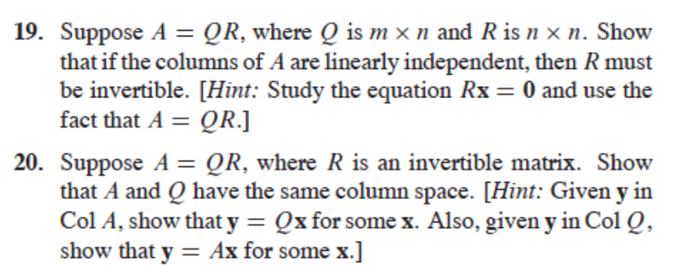

Ans:

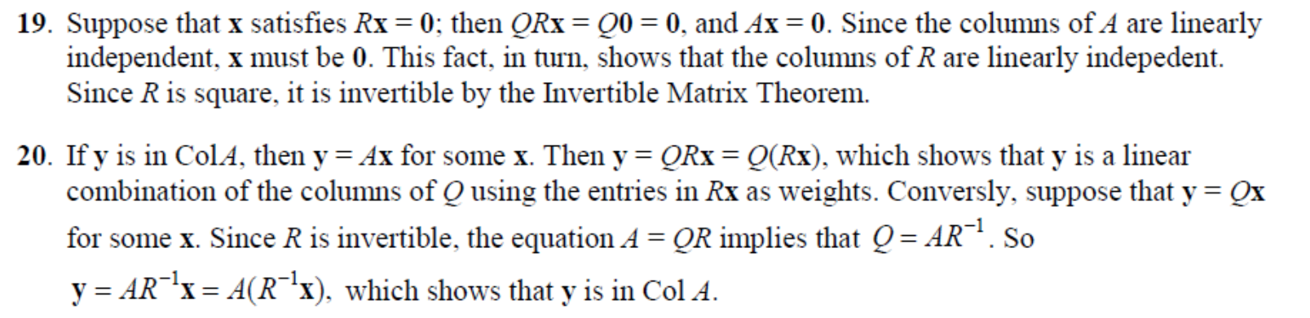

For 19, can also use dim col(A) = n, since col A are independent. Hence dim (ker) = 0 by rank theorem, implying x = 0. Hence R is invertible…